PRACTICAL NO 06
Configure IOS Intrusion Prevention System (IPS) Using the CLI

a. Enable IOS IPS.
b. Modify an IPS signature.
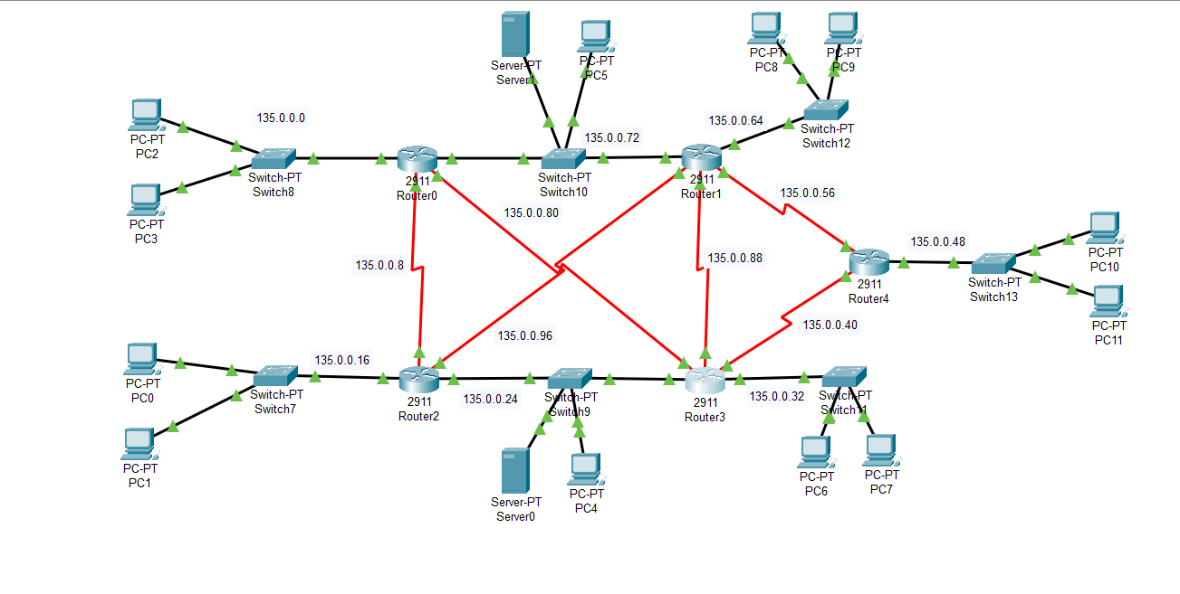
Installing the securityK9 package on Router3
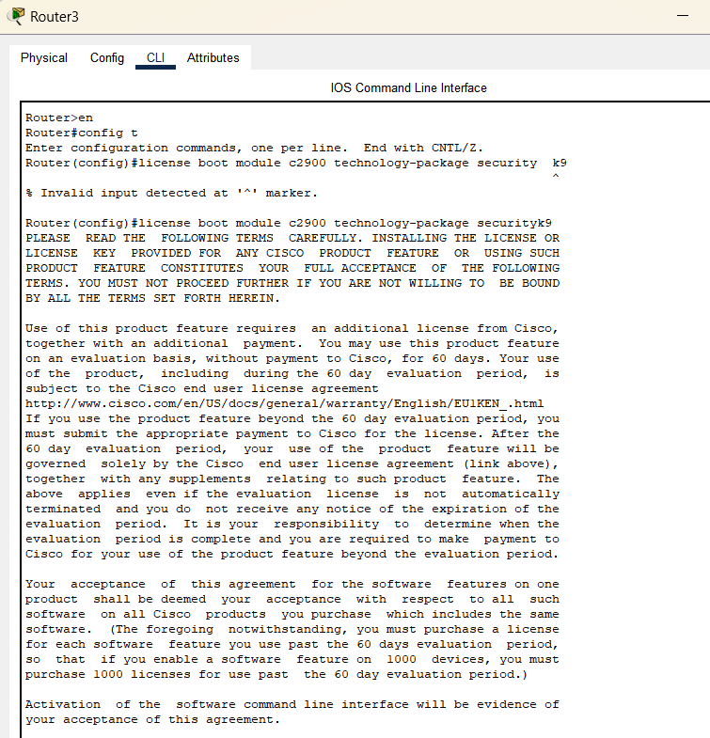

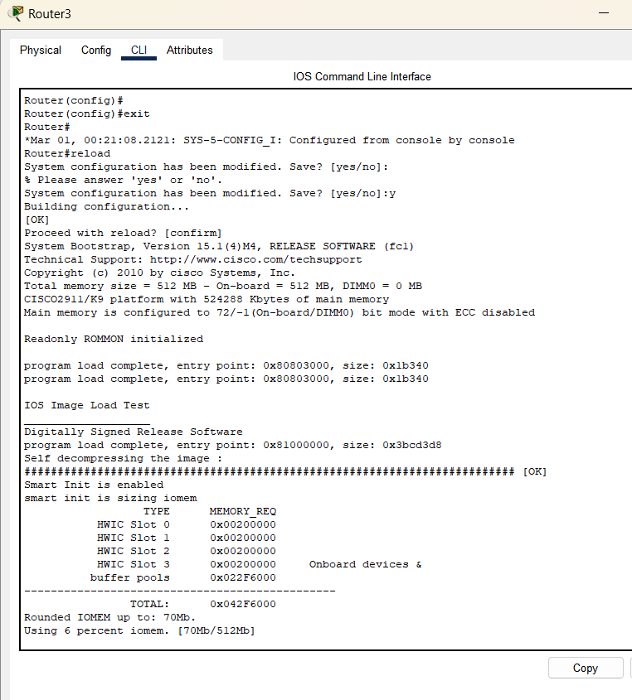
Commands to enable ios_ips on Router3 with syslog server
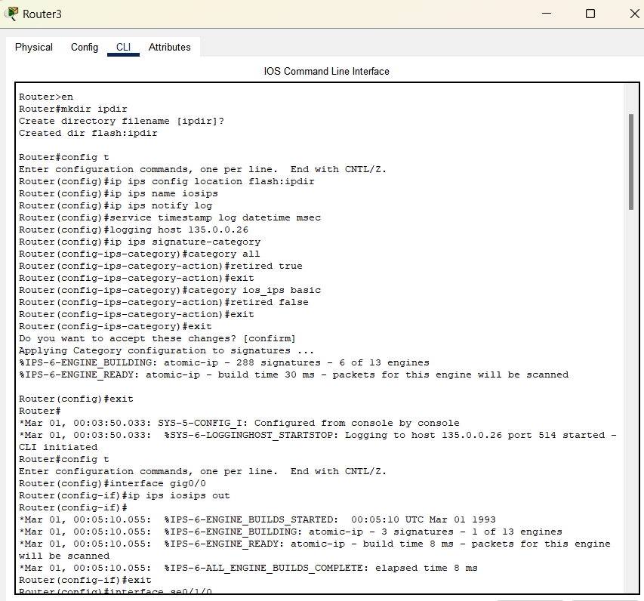
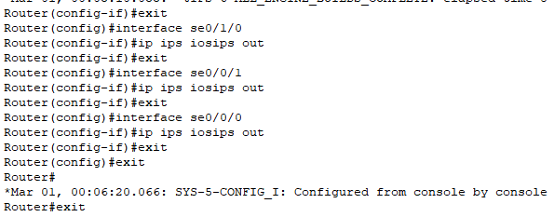
Below are the commands To modify the signatures
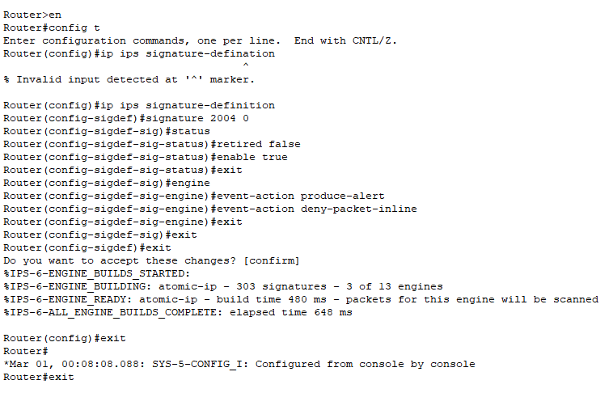
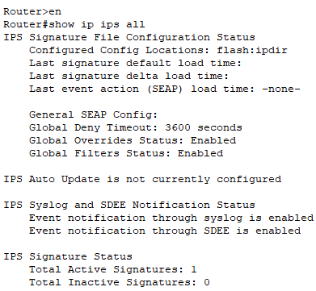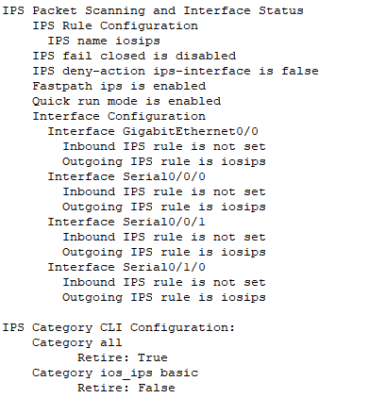

Before configuring ios_ips the devices were able to ping the devices from ios_ips enabled interface
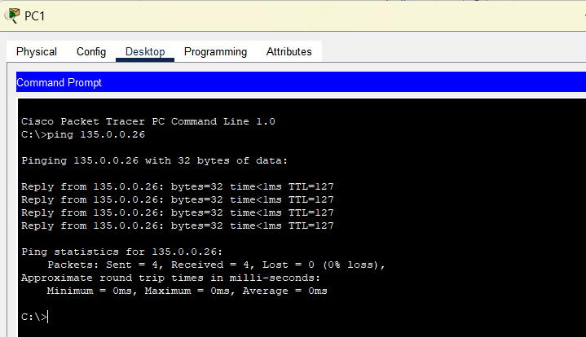
After configuring ios_ips outside devices are not able to ping the from ios_ips enabled interface
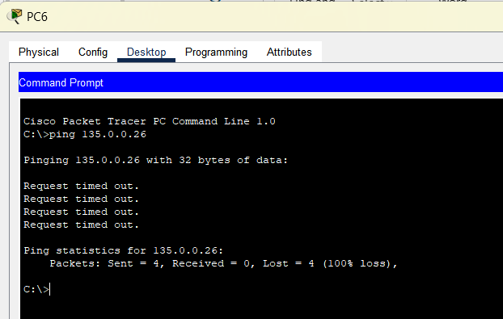
Logs:
